**CTF Challenge: Ethical Hacking Informative CTF Challenges**

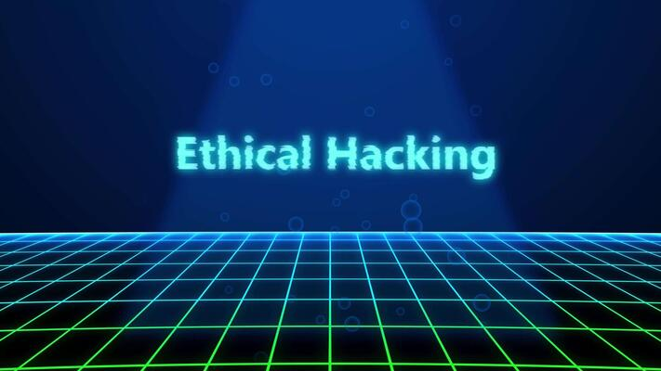

# **1. What is Ethical Hacking?**

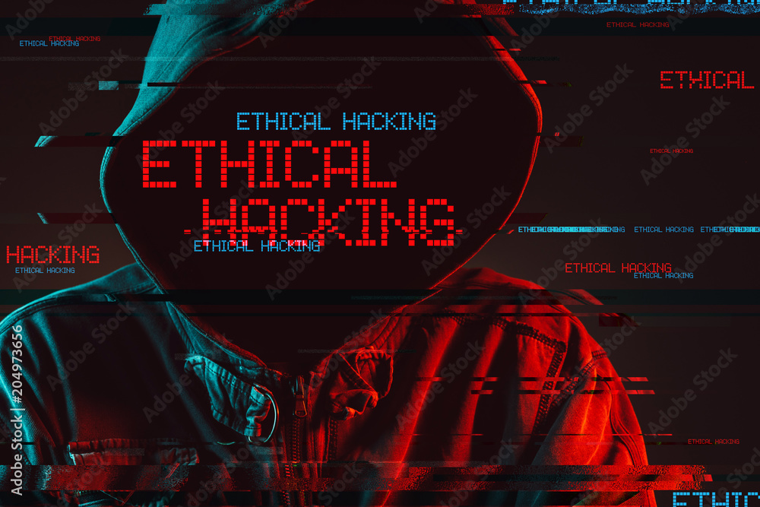

Ethical hacking is like being a friendly detective for computers and networks. It's about finding and fixing problems before bad guys can exploit them. Ethical hackers use their skills to help make technology safer.

# **2. Key Concepts of Ethical Hacking:**

* **Purpose:** Improve security by finding and fixing weaknesses.
* **Authorization:** Ethical hackers have permission to test systems.
* **Identifying Vulnerabilities:** Search for weaknesses in systems.
* **Exploitation:** Test to see if weaknesses can be exploited.
* **Reporting and Fixing:** Report vulnerabilities to fix them.
* **Continuous Learning:** Stay updated on new threats and technologies.
* **Responsible Disclosure:** Report vulnerabilities to system owners before disclosing them publicly.

# **3. Types of Hackers**

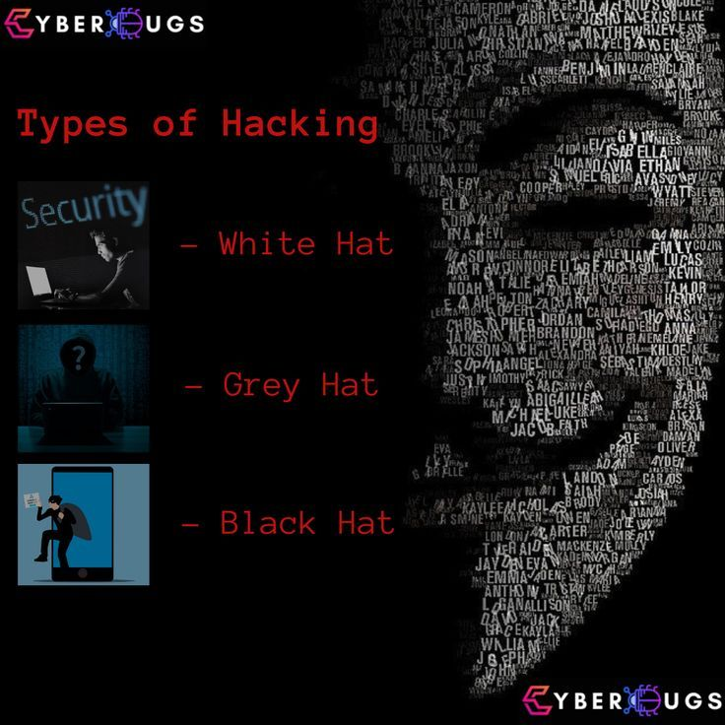

**a. Black Hat Hackers:**

The bad guys. They break into systems without permission to steal information, cause damage, or make money illegally.

**Example:** Stealing credit card information from an online store.

**b. White Hat Hackers:**

The good guys. They use their hacking skills to help keep computer systems safe.

**Example:** Finding and fixing security problems in a company's website.

**c. Gray Hat Hackers:**

In between. They might break into systems without permission but not to cause harm.

**Example:** Highlighting weaknesses in a system to gain attention, even if it means breaking the law.

# **4. Rules and Ethics for Ethical Hacking:**

* Get permission before testing.
* Follow laws and regulations.
* Do not cause harm to systems or data.
* Respect confidentiality and privacy (follow the CIA triad - Confidentiality, Integrity, Availability).
* Report vulnerabilities responsibly.
* Maintain professionalism and integrity.

# **Capture the Flag (CTF) Challenges**

Flag 1: How many types of hacker are listed above?

Answer: 3

Flag Captured

Flag 2: What must ethical hackers obtain before testing systems?

Answer: Permission

Flag Captured

Flag 3: Who are Black Hat Hackers?

Answer: Bad Guys

Flag Captured